38.76: a) The final energy of the photon is 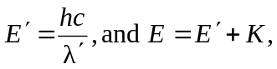 where K is the kinetic energy of the electron after the collision. Then,
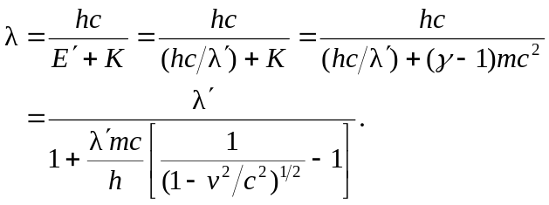
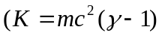 since the relativistic expression must be used for three-figure accuracy).
b) 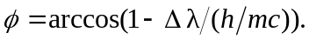
c) 